**Shell – Final Case Study**

*By Yuva Sahith Varma Sangaraju*

**Scenario:**

Streamline Solutions Inc. - Optimizing Software Deployment

**Problem Statement:**

Implementing a Seamless CI/CD Workflow for a Spring Boot Application using Azure Boards, Azure, Git, Maven, Docker, Github, Github Actions

**Activities:**

# Project Management Setup:

The development team will establish Azure Boards to manage the Agile/Scrum project's progress, including creating a Project Board, Backlogs Board, Sprints/Iterations and Tasks Board.

I created work items of types – Epic, Feature, Product Backlog Item, Task and Test. I also linked them together to show a hierarchy in Backlogs. I assigned a user story to two different sprints.

***Work Items:***

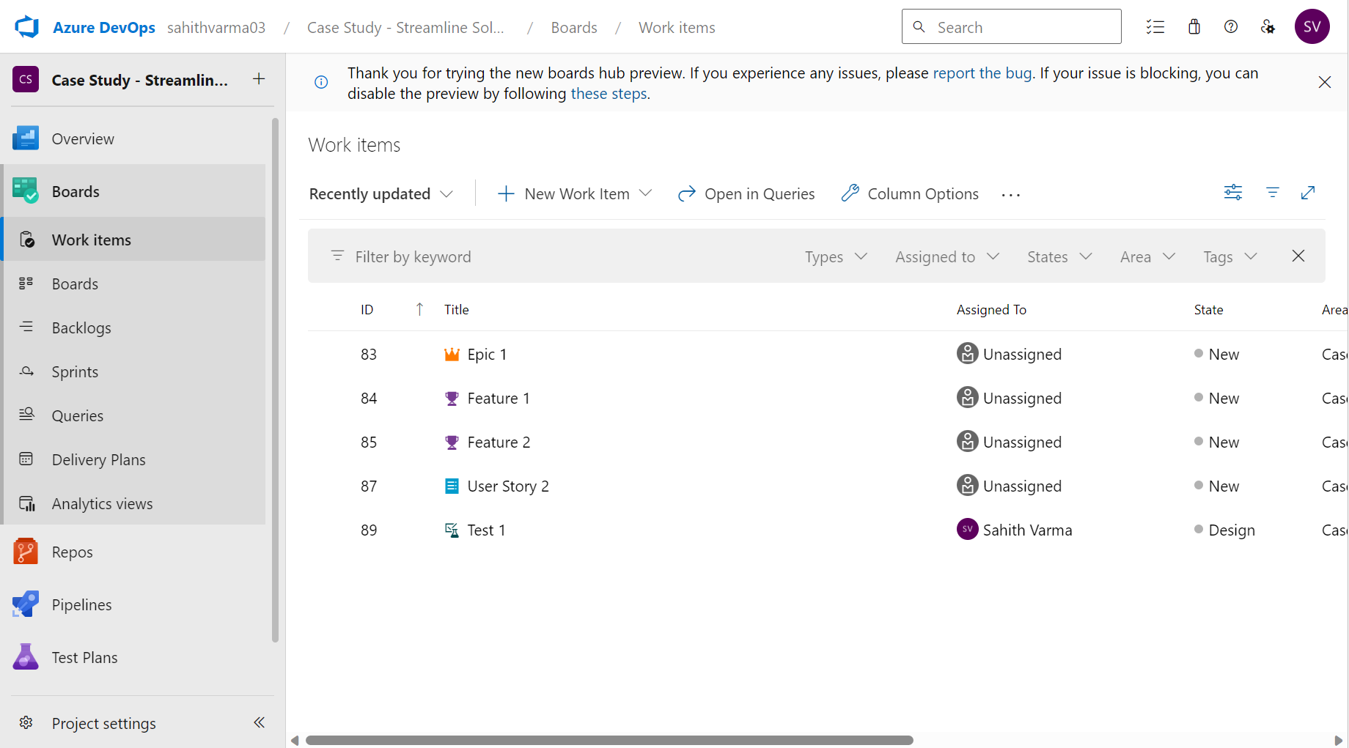

***Boards:***

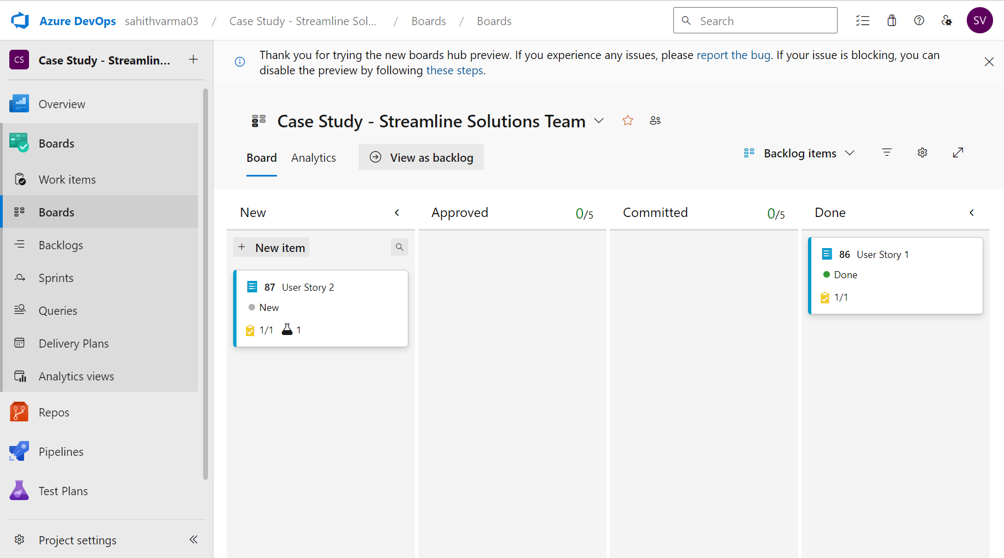

***Backlogs:***

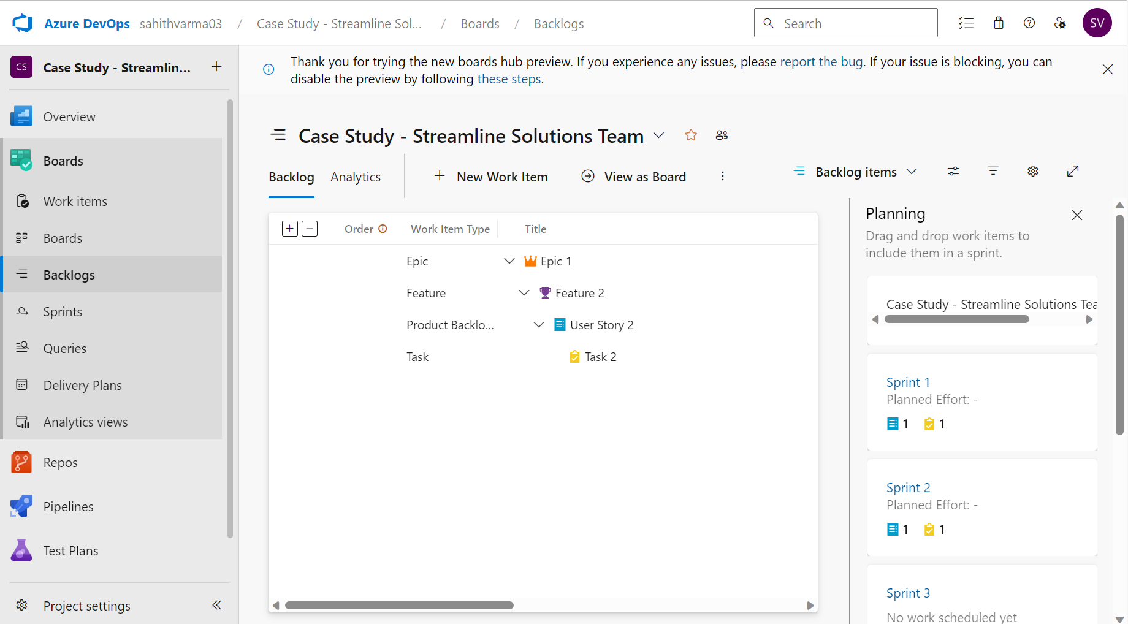

***Sprint:***

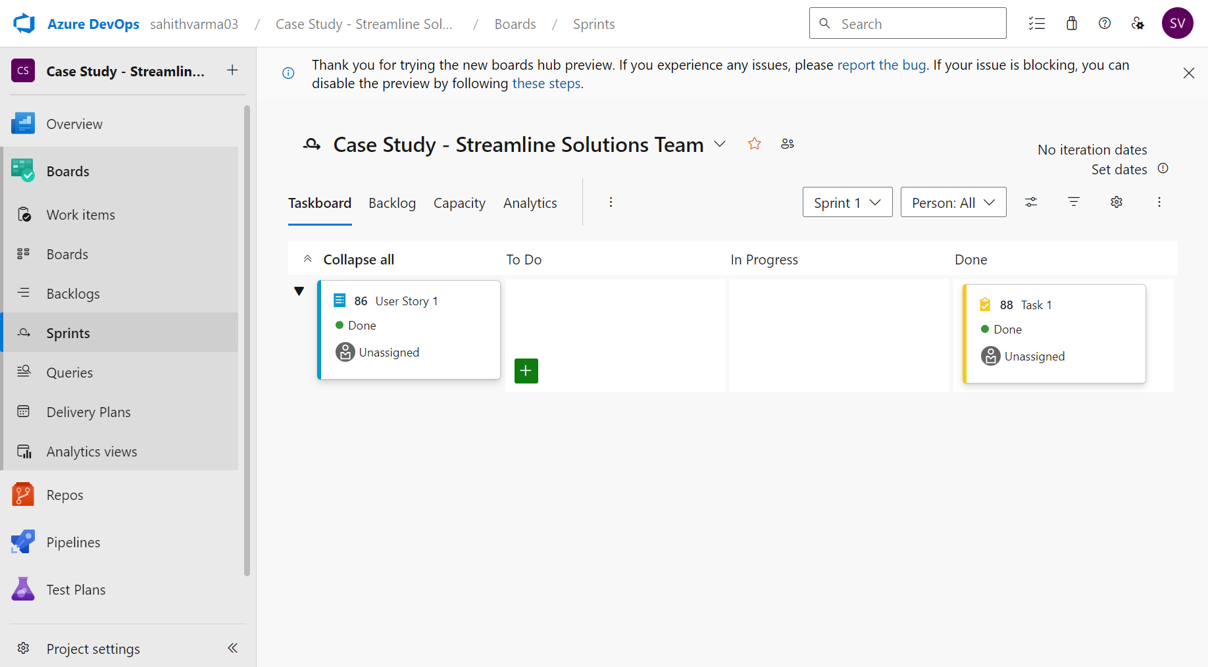

# GitHub Repository and Feature Branching:

Developers will fork the main GitHub repository (https://github.com/hrb1989/shell_7_foundation_Java_Spring) into their local environments. They will create feature branches to work on specific enhancements or tasks related to the Java Spring Boot application.

***Feature Branches:***

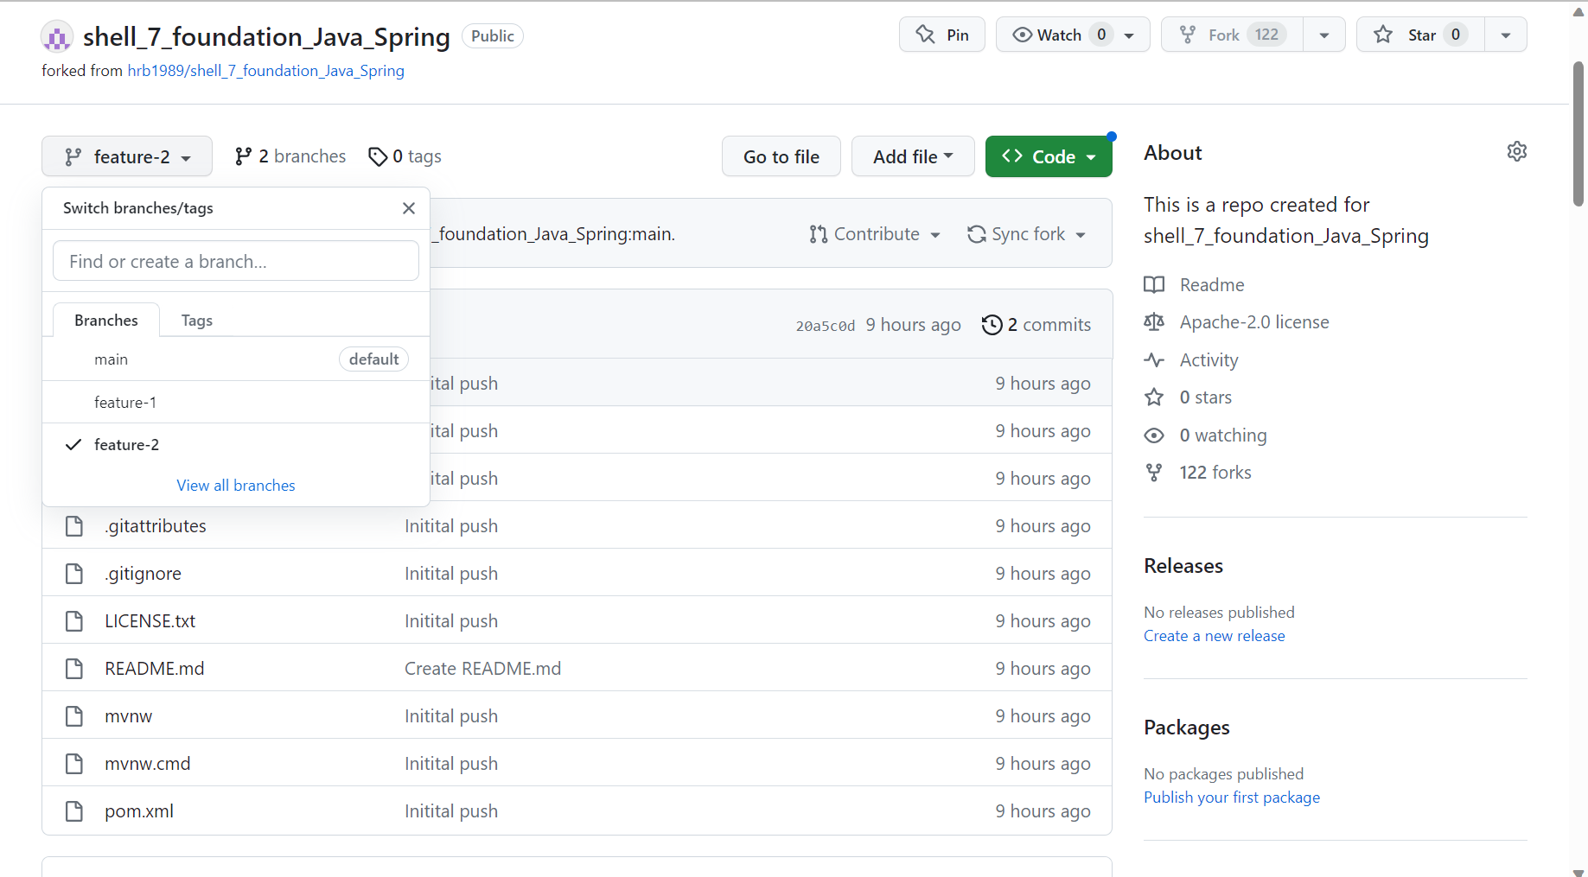

***Pull Request:***

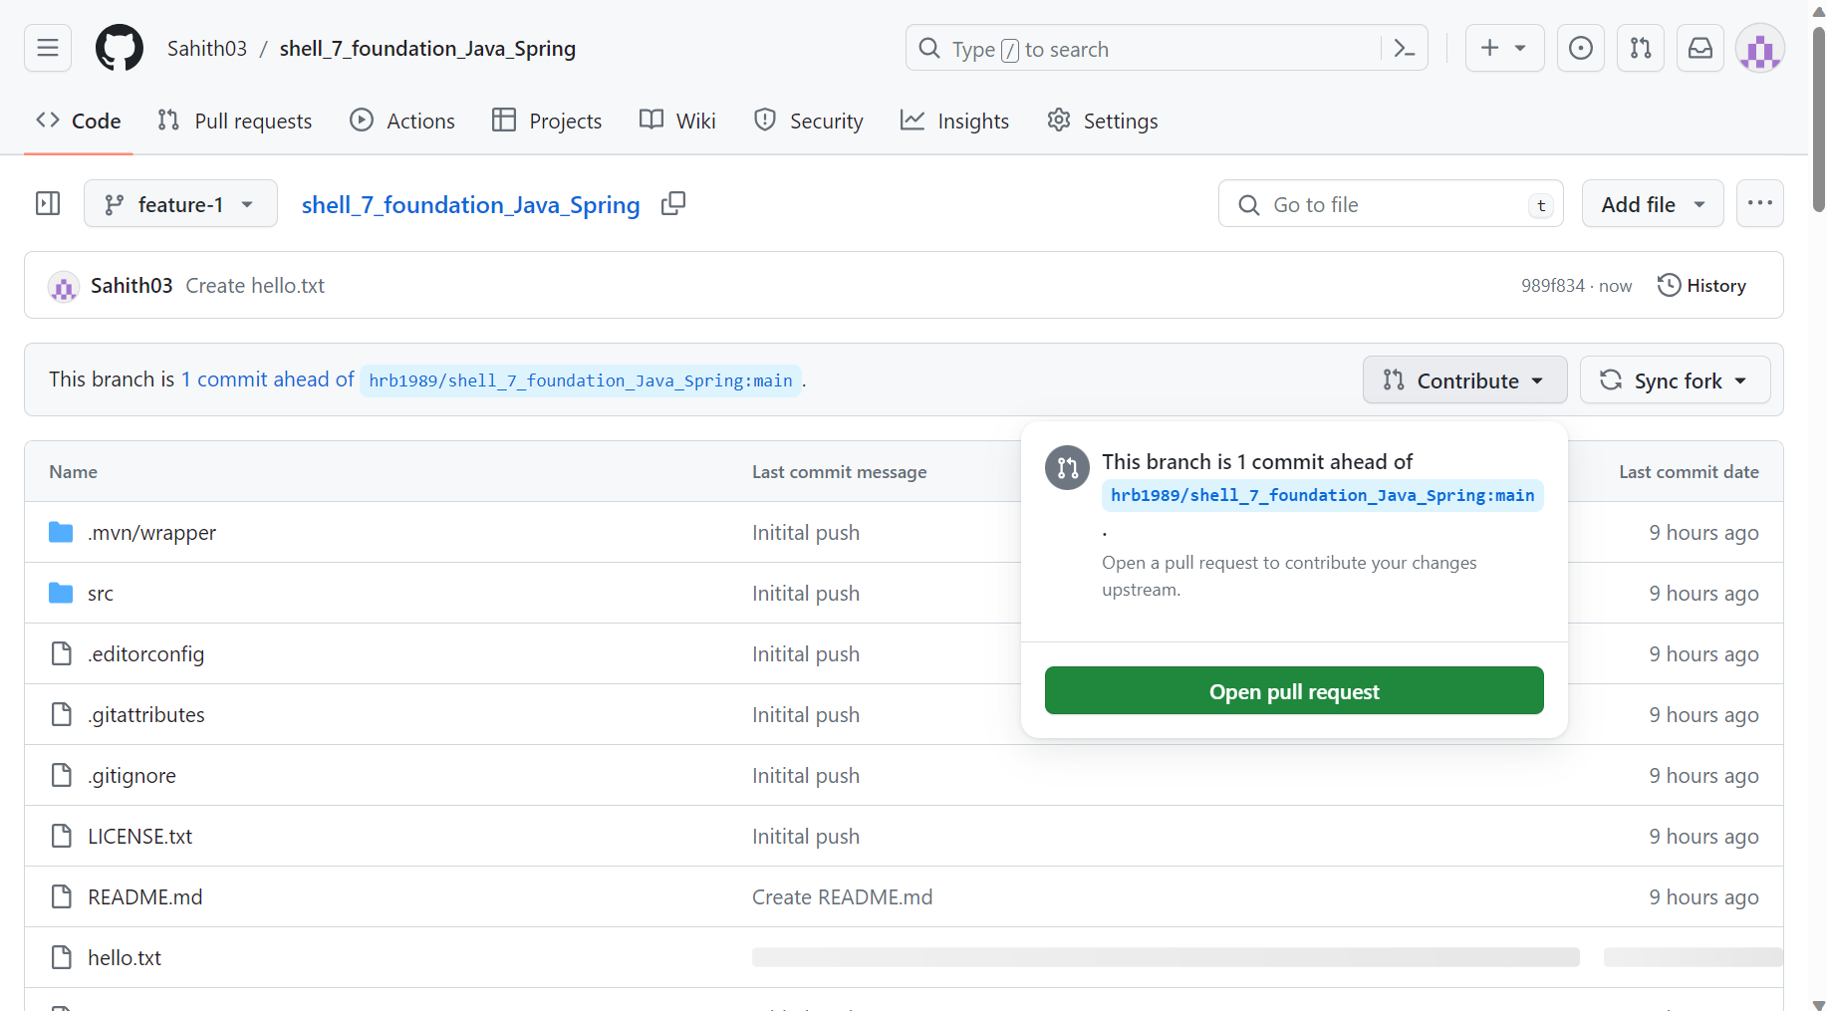

# Azure VM Configuration:

The IT team will configure a virtual machine (VM) on Azure with specific performance and resource specifications to accommodate the development needs.

Respective Location, Resource Group, B2s, Ubuntu, Username, Password, Standard HDD, Basic Dynamic Public IP.

***Virtual Machine:***

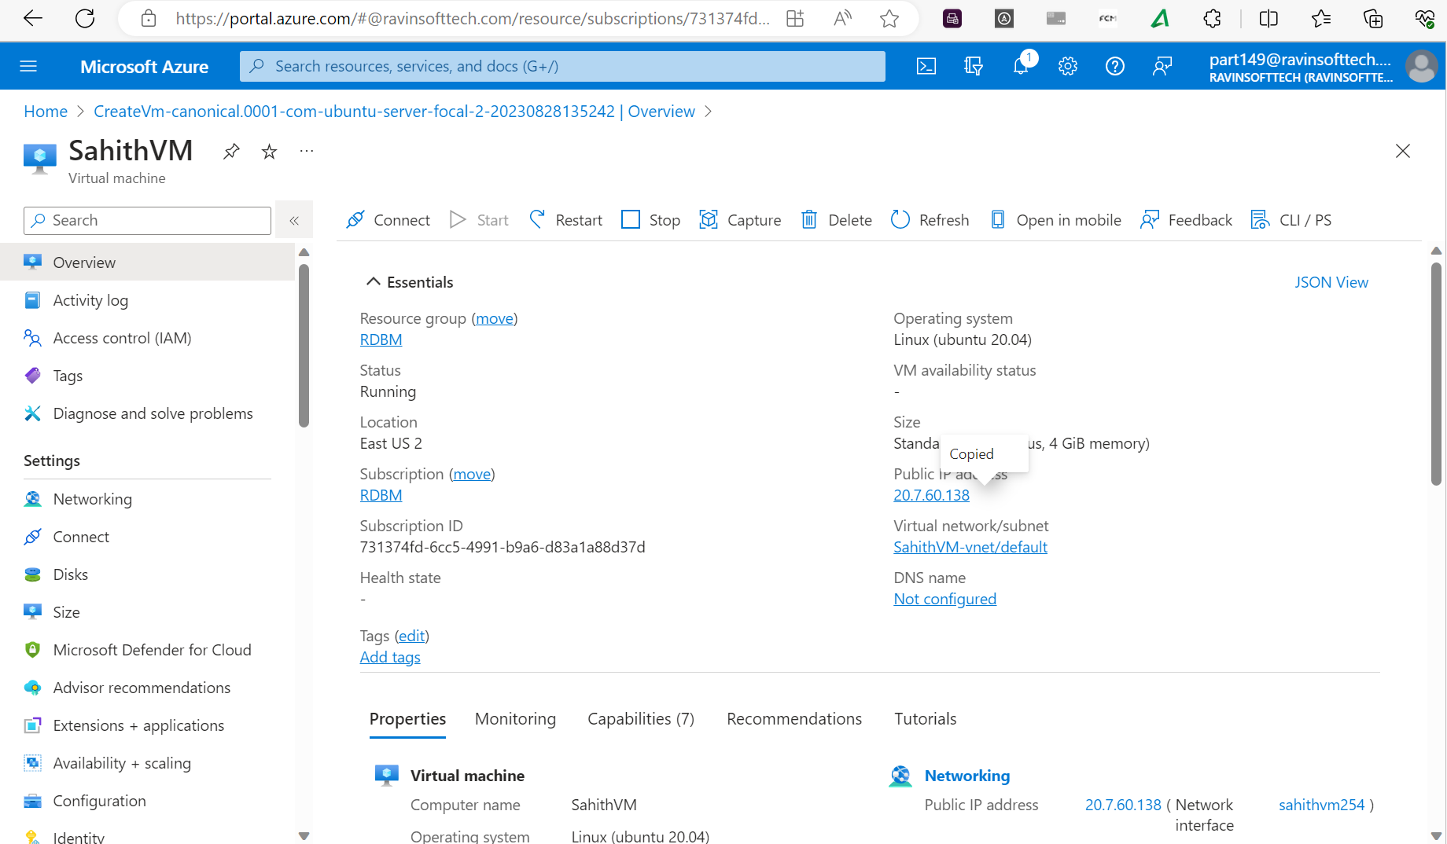

***Connecting to Virtual Machine using ssheasy:***

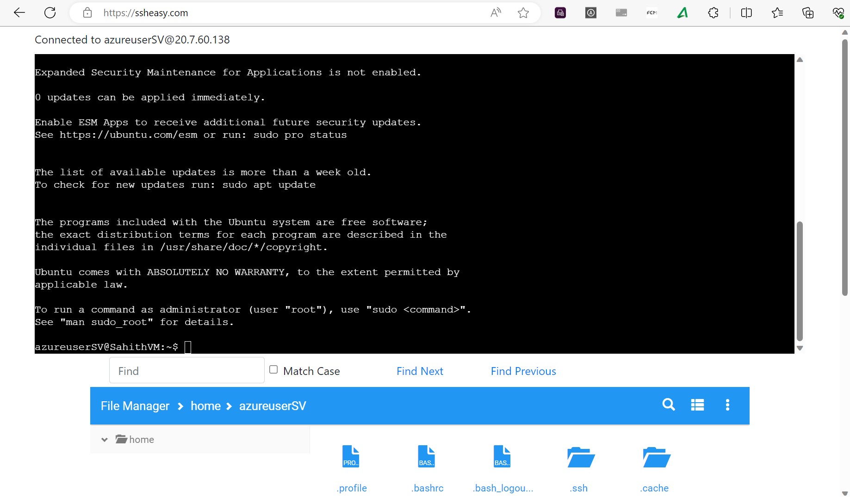

# Maven-Based Build Process:

The development team will install Maven on the Azure VM and define a Maven-based build process. This process will generate a Java Application Archive (JAR) file from the Java Spring Boot application's codebase.

***Installing Maven:***

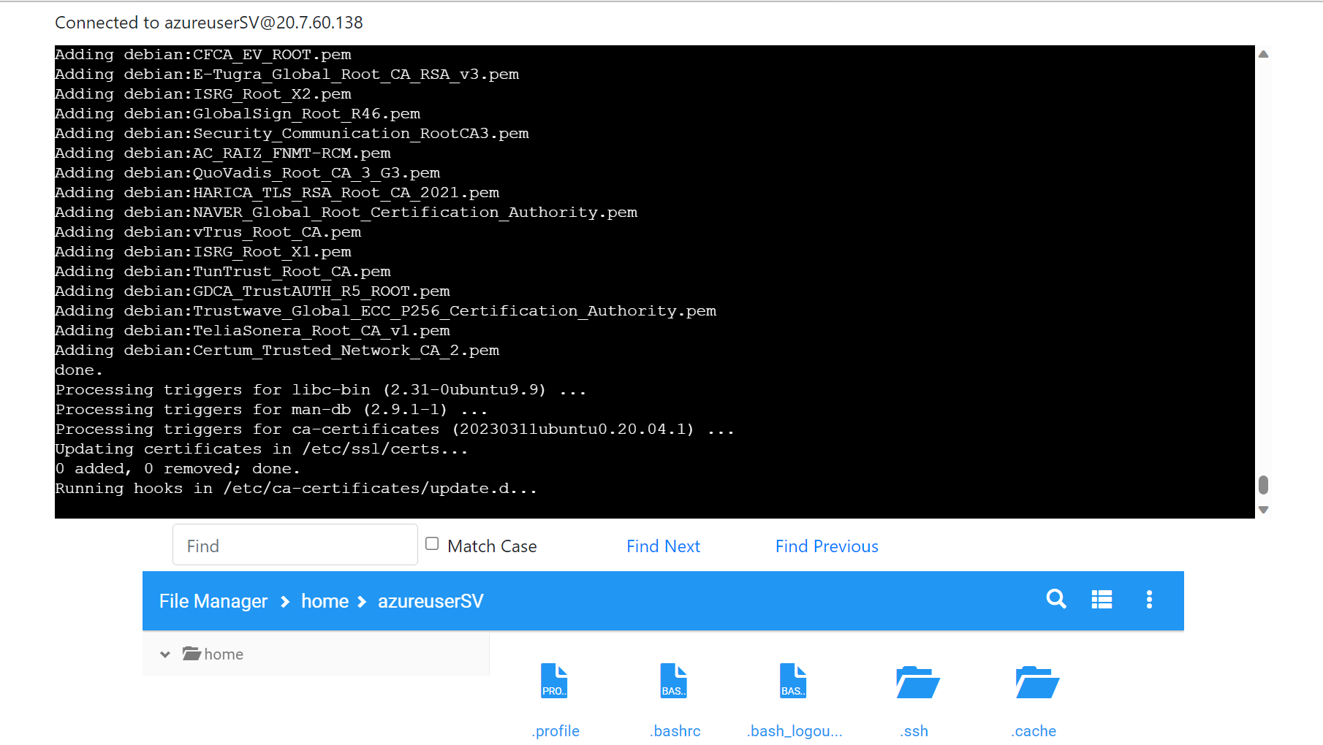

***Maven Clean Success:***

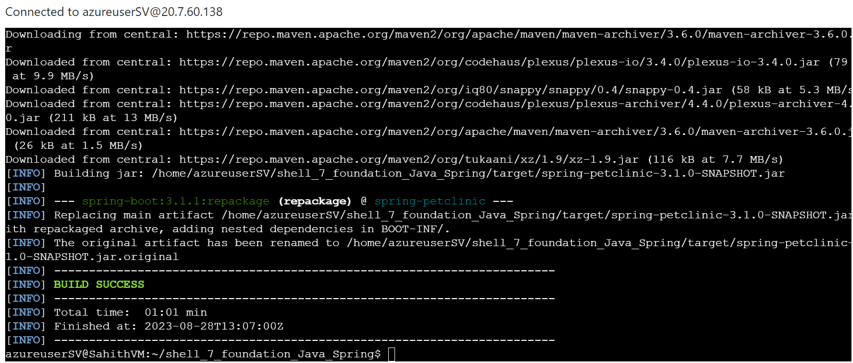

***Maven Build Successful:***

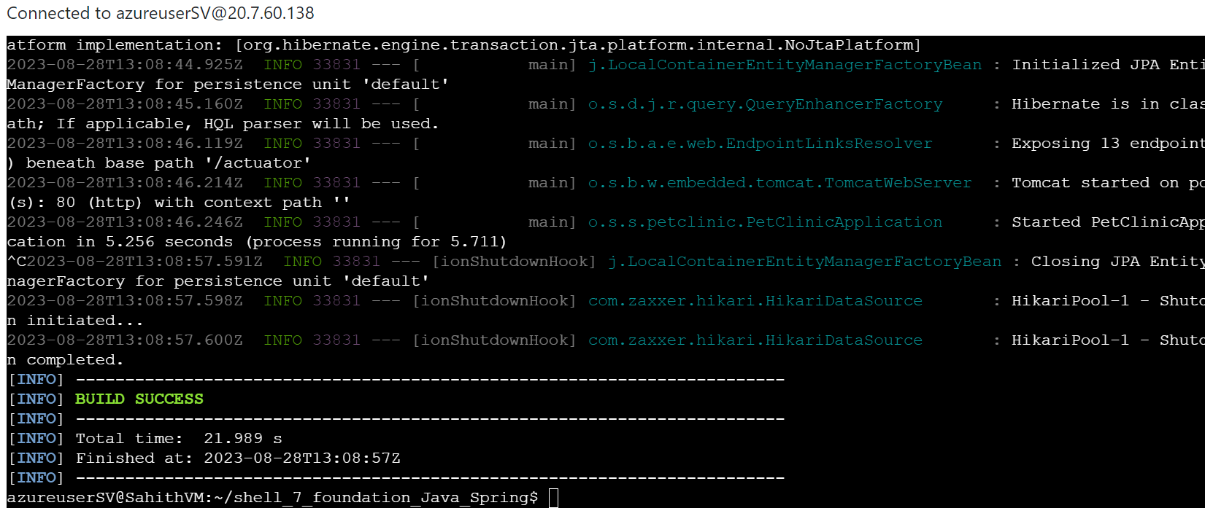

# Prometheus Monitoring Integration:

The IT operations team will install Prometheus on the Azure VM. They will configure Prometheus to monitor the local environment and explore the possibility of monitoring the Java Spring Boot application.

***Installing Prometheus:***

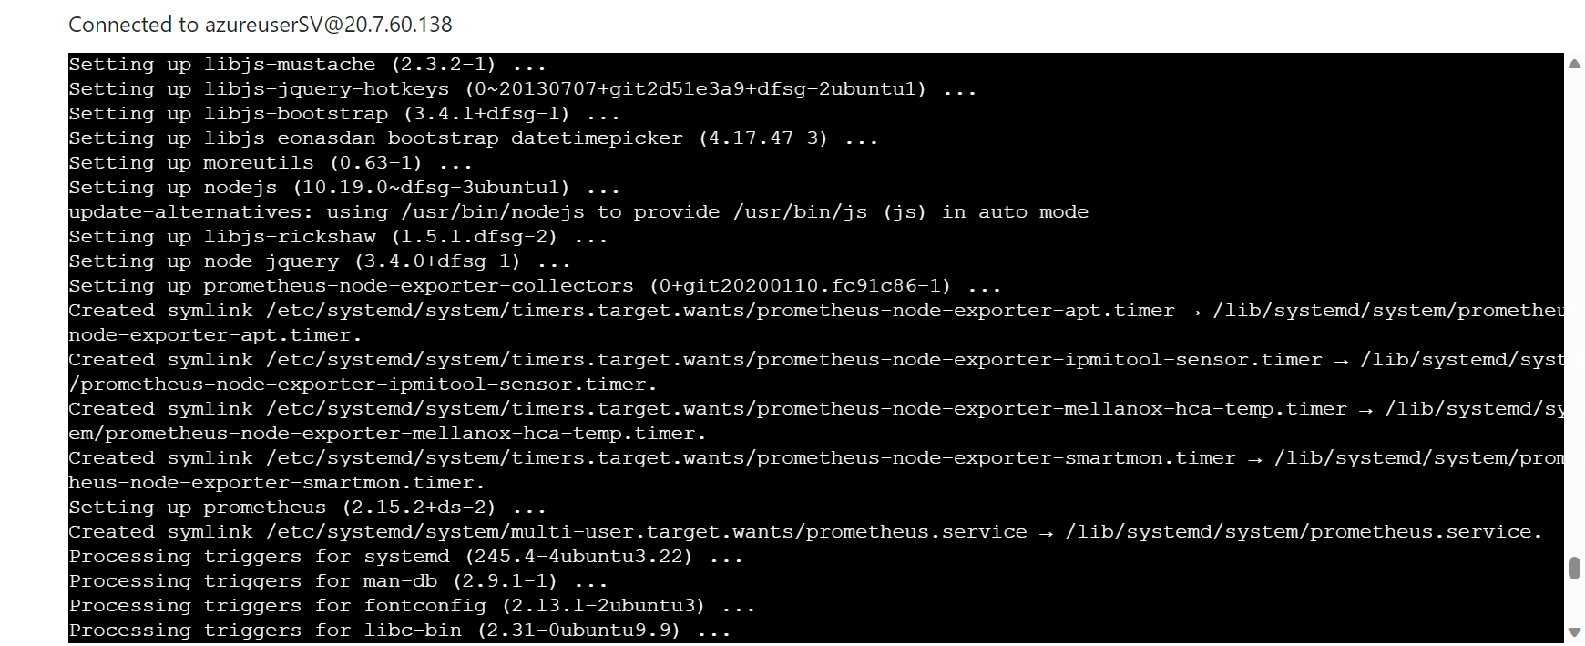

# Docker Containerization:

On the Azure VM, the development team will craft a Dockerfile tailored for the Java Spring Boot application. This Dockerfile will define the steps necessary to package the application into a Docker container.

***Installing Docker:***

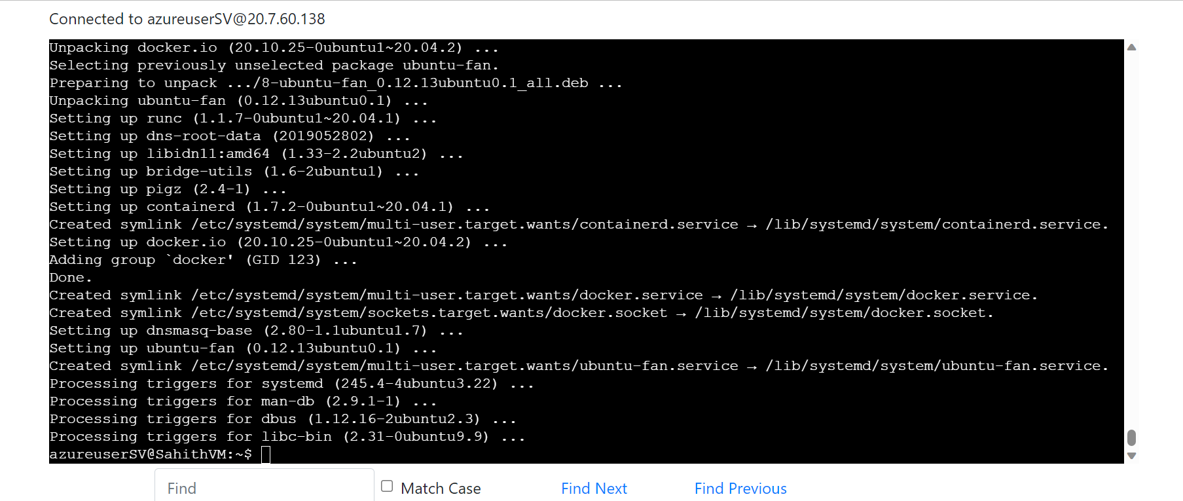

***Building Docker Image:***

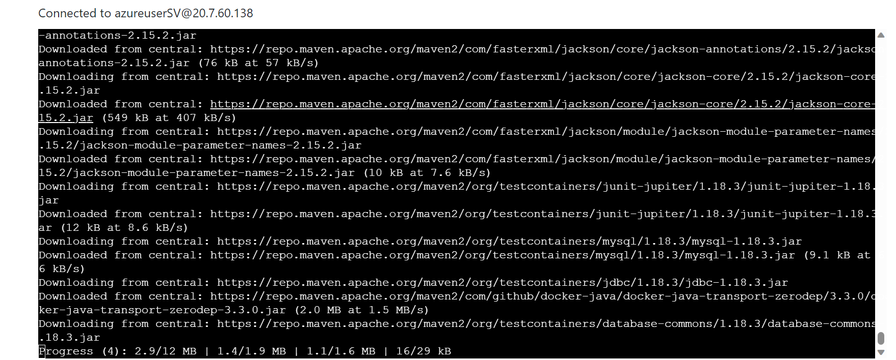

***Running Docker Image:***

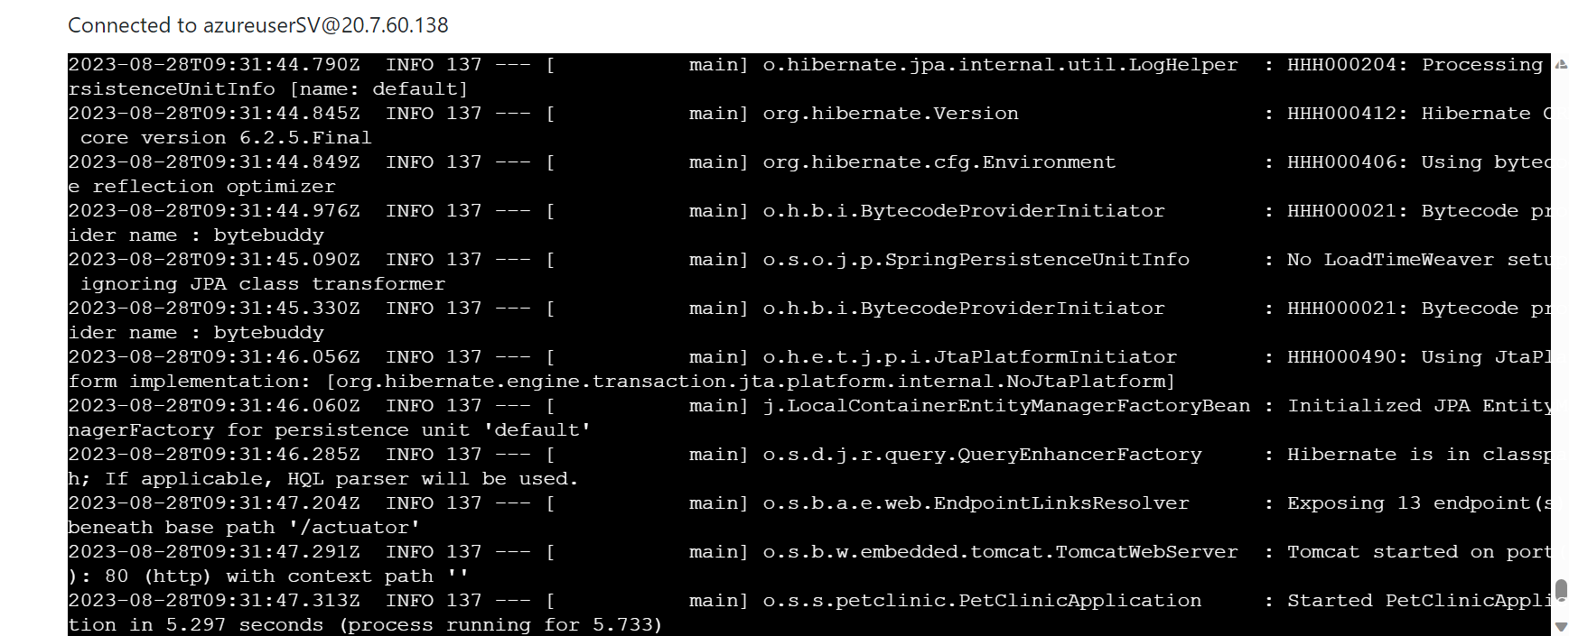

***Listing Docker Images:***

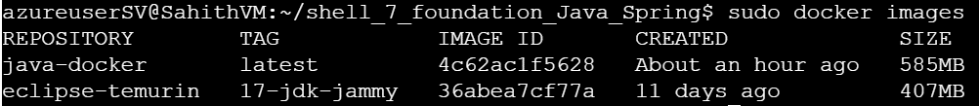

***Listing Docker Containers:***

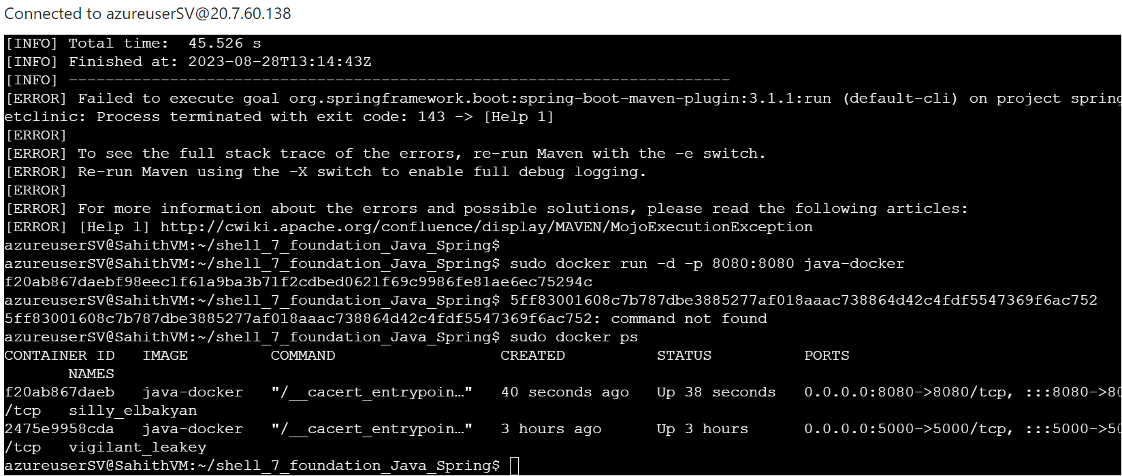

# Azure Web App Configuration:

The IT team will configure a Azure Web App on Azure with specific performance and resource specifications to accommodate the development needs.

Respective Location, Resource Group, Docker Container and NOT with CODE, ASP – F1

***Creating Web App:***

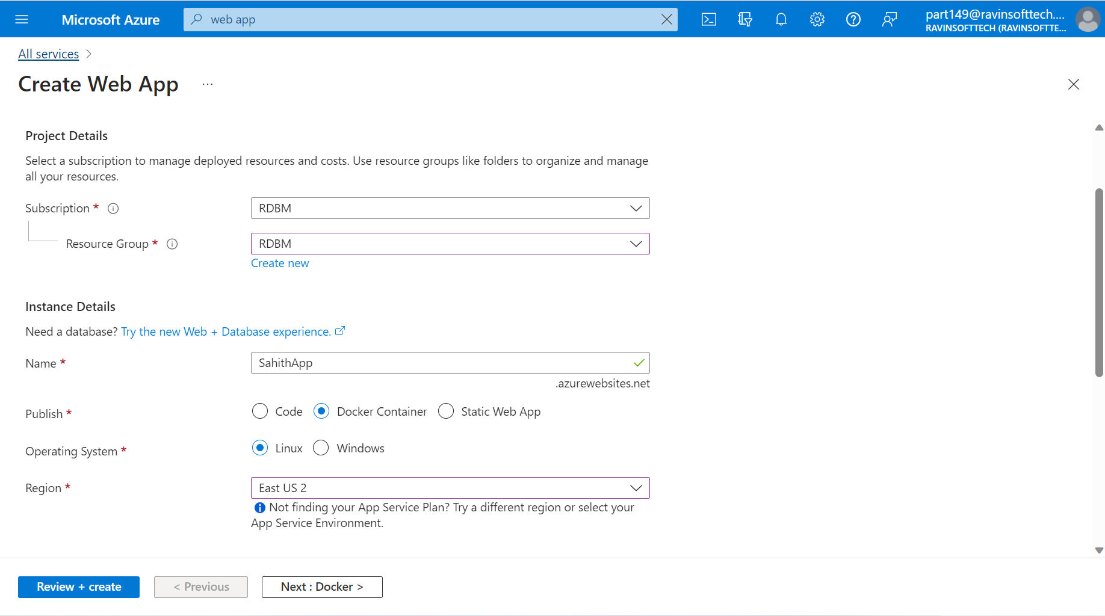

***Deployed Web App:***

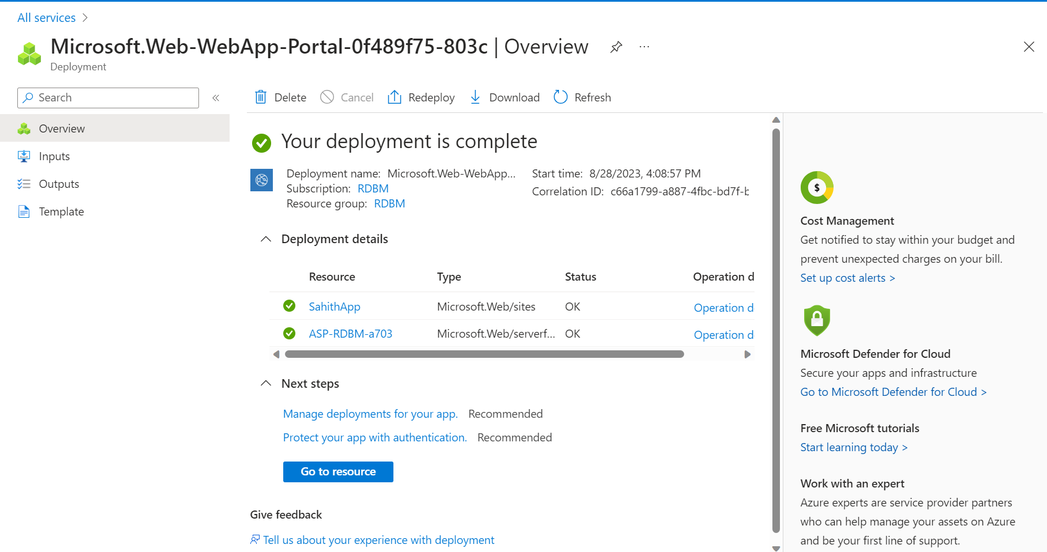

# Pull Request Collaboration:

Developers will work on features or tasks within their feature branches. When ready, they will initiate pull requests (PRs) from their feature branches to the main/master branch on GitHub. Collaborative discussions and code reviews will take place during this process.

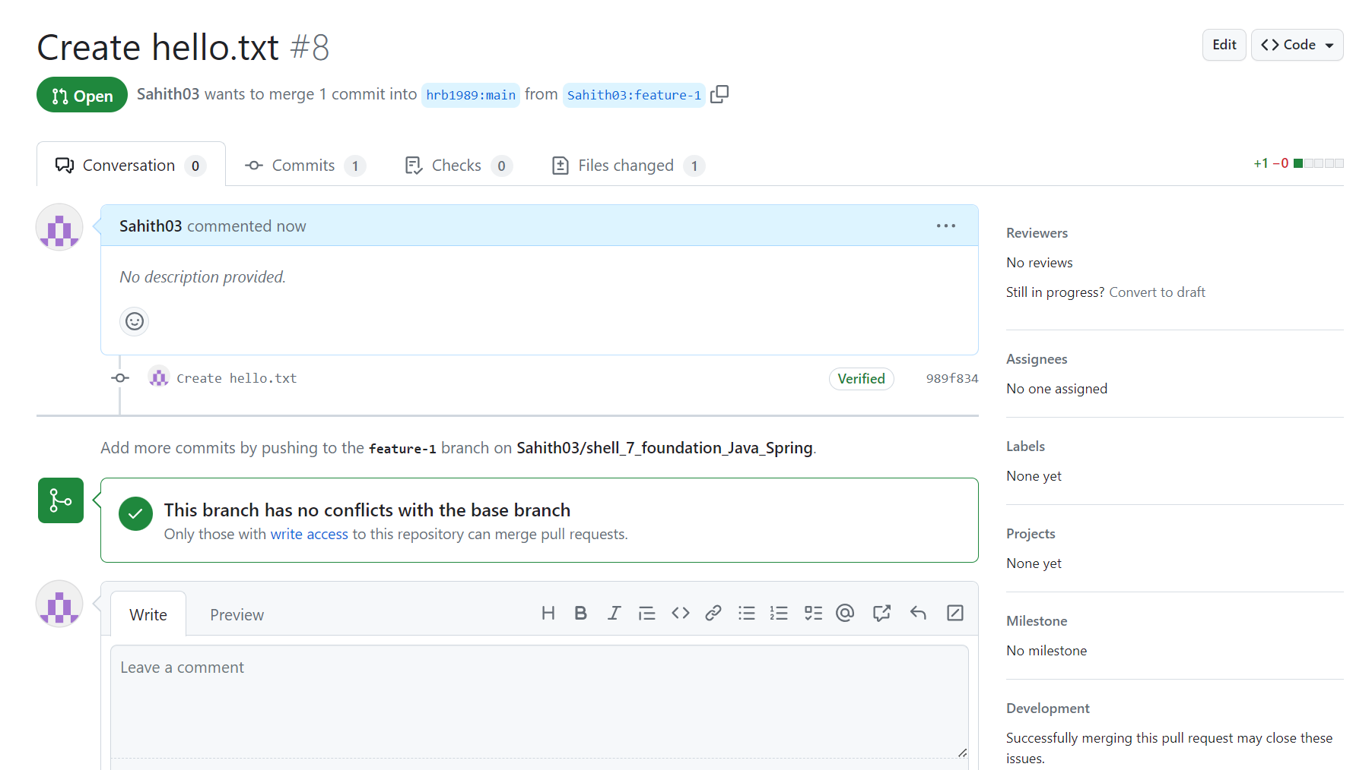

# GitHub Actions Workflow Implementation:

The development team will outline a GitHub Actions workflow triggered by PRs on the main/master branch. This workflow will automate essential tasks such as building, testing, Deploying and ensuring code quality. This workflow will also incorporate a continuous Integration & continuous deployment (CD) process. This process will also facilitate the deployment of the Docker container to an Azure App Service.

***Creating a YAML file via a new workflow in GitHub Actions:***

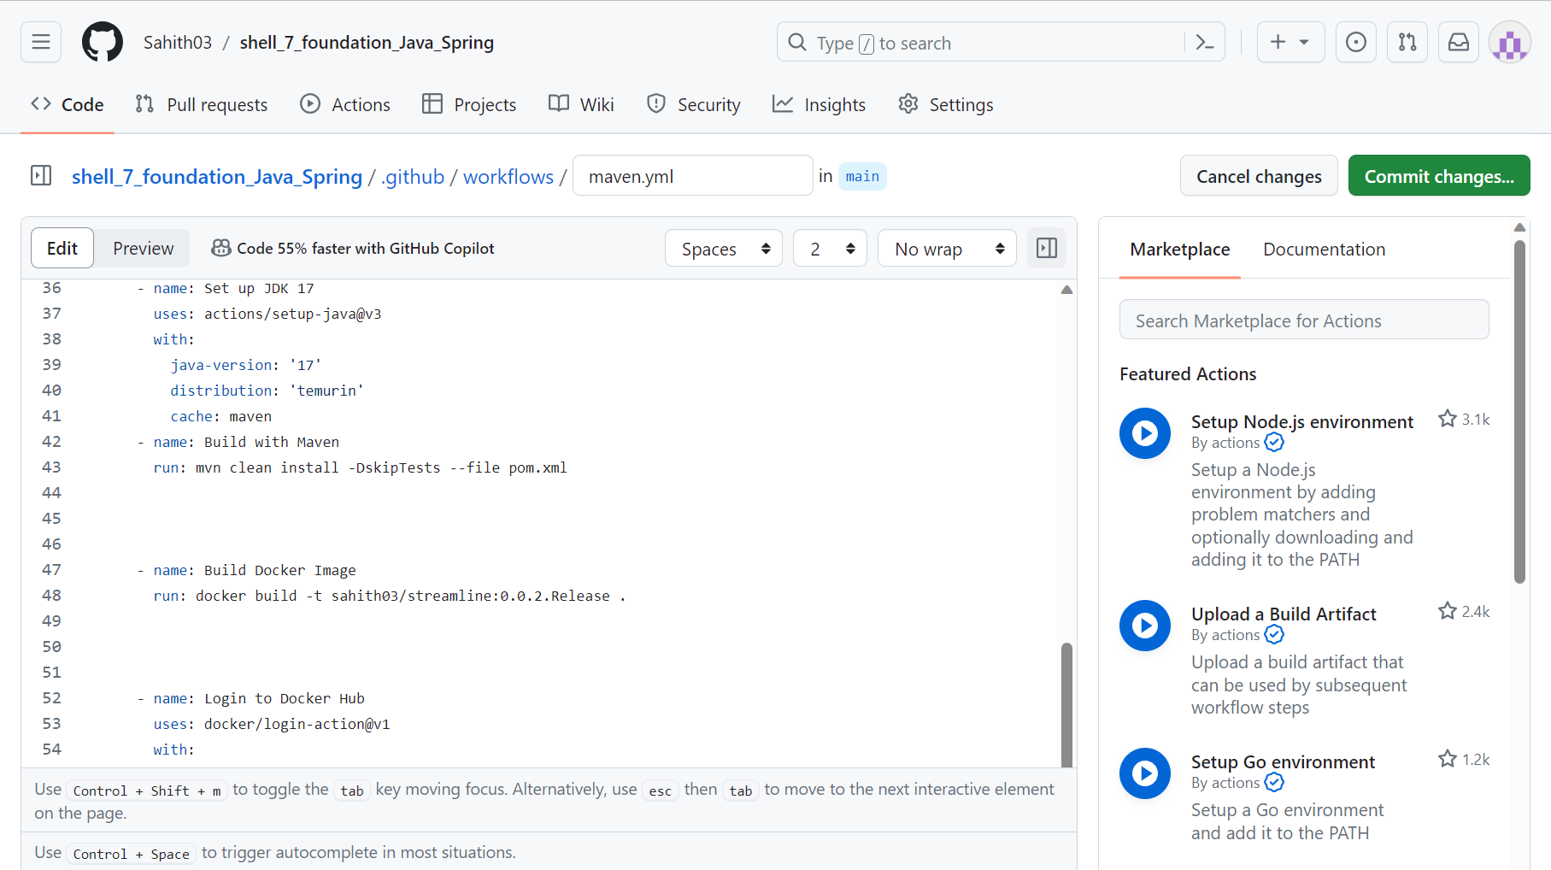

# Local Testing of Azure Web App:

Upon making changes to the code from the feature branch and post approval of a PR to main branch, with the help of Automated Github Actions, the webapp needs to be updated. Developers will locally test the deployed Azure Web App's webpage on their machines. They will ensure that the application functions seamlessly and provides an optimal user experience.

# Azure Boards Task and Sprint Closure:

The development team will review and manage tasks on the Azure Boards Tasks Board. Completed tasks will be closed, and task statuses will be updated. Additionally, the progress of sprints on the Azure Boards will be evaluated and completed sprints will be closed.

***Test Plans:***

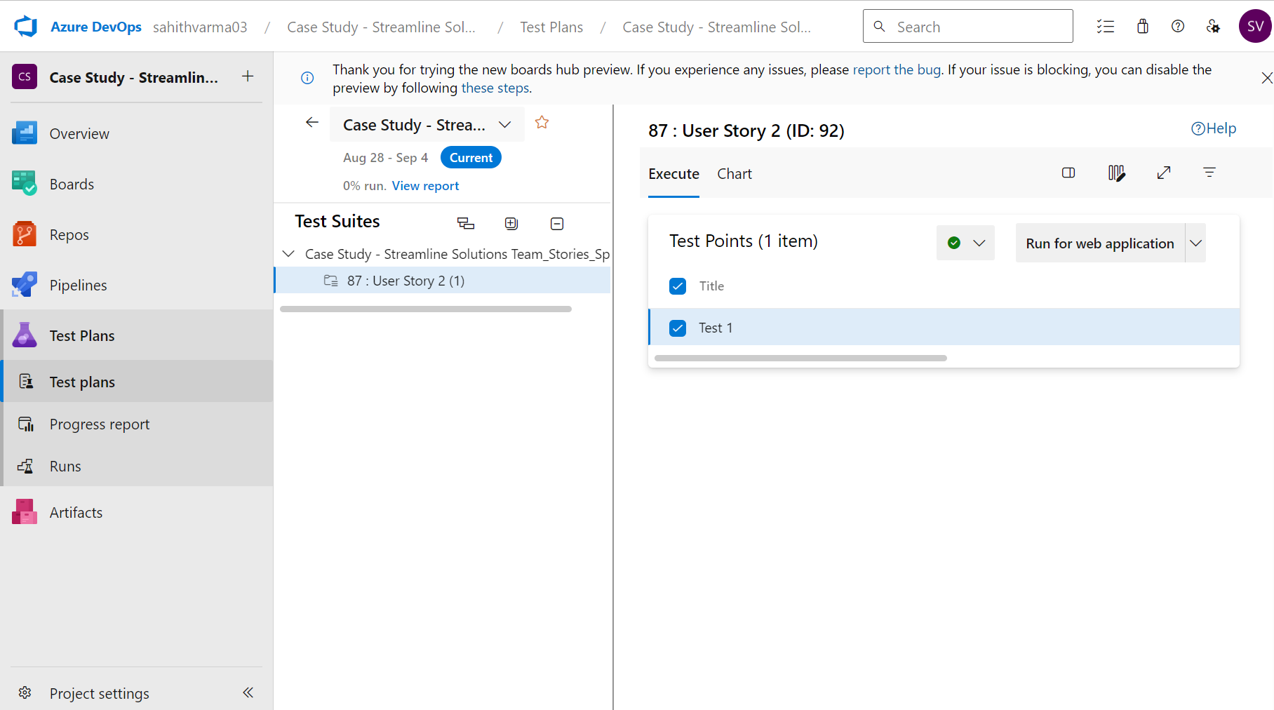

***Runner:***

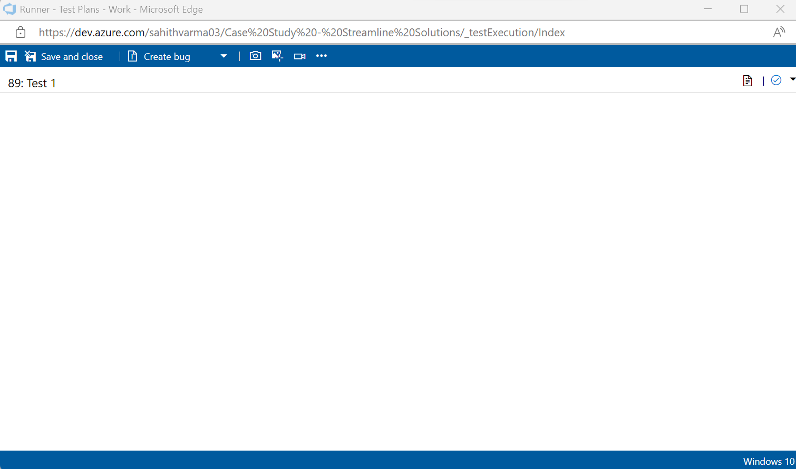

# Project Closure and Reflection:

Once the CI/CD workflow is successfully implemented, Streamline Solutions Inc. will reflect on the project's journey. The team will document lessons learned, celebrate achievements, and identify areas for further improvement.

***Sprint Closure:***

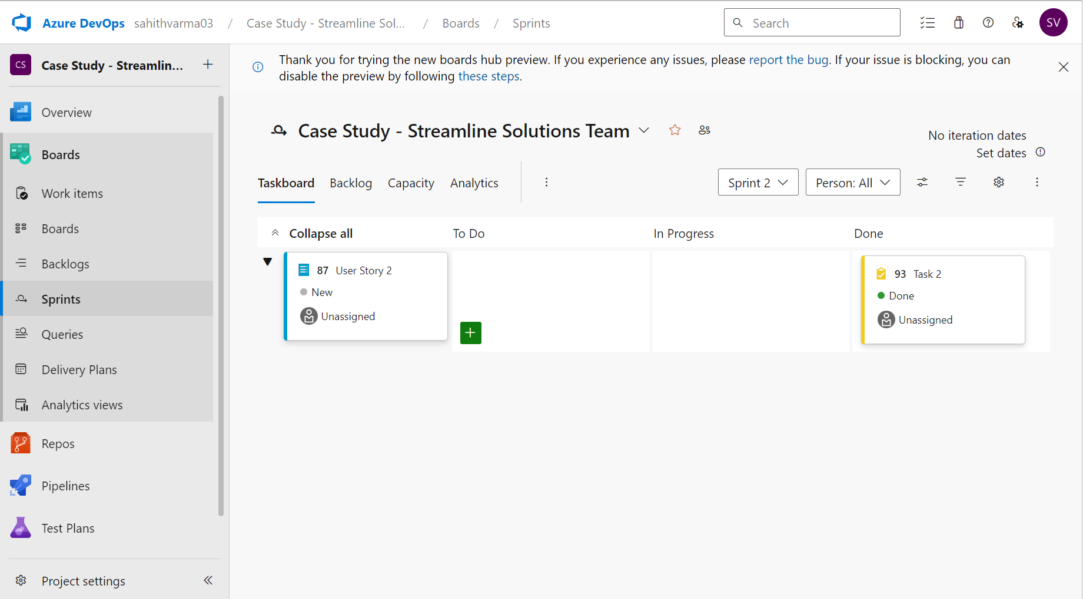

# Outcome:

By methodically applying the CI/CD approach, Streamline Solutions Inc. aims to achieve quick and reliable software deliveries. The business' Java Spring Boot application will readily reach customers, providing a top-notch user experience and building the foundation for further innovation.